SUMMER
STARTS
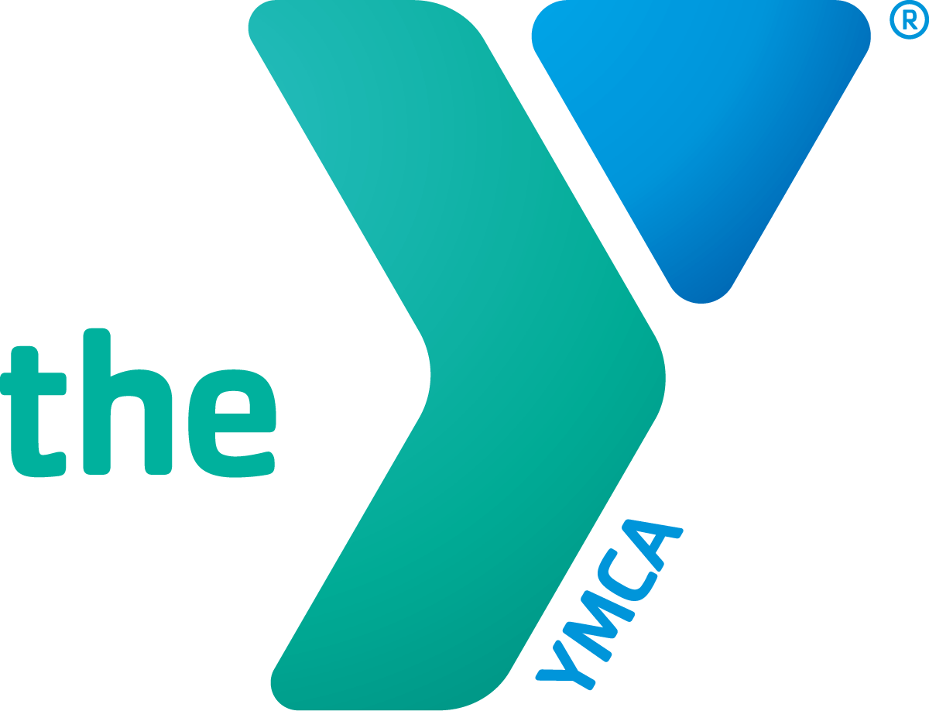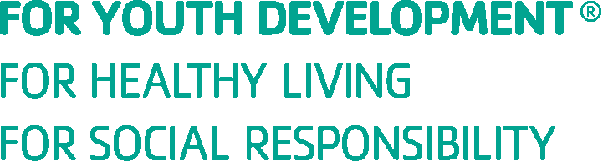
HERE

2022 Summer Day Camp Application

YMCA OF THE PALM BEACHES
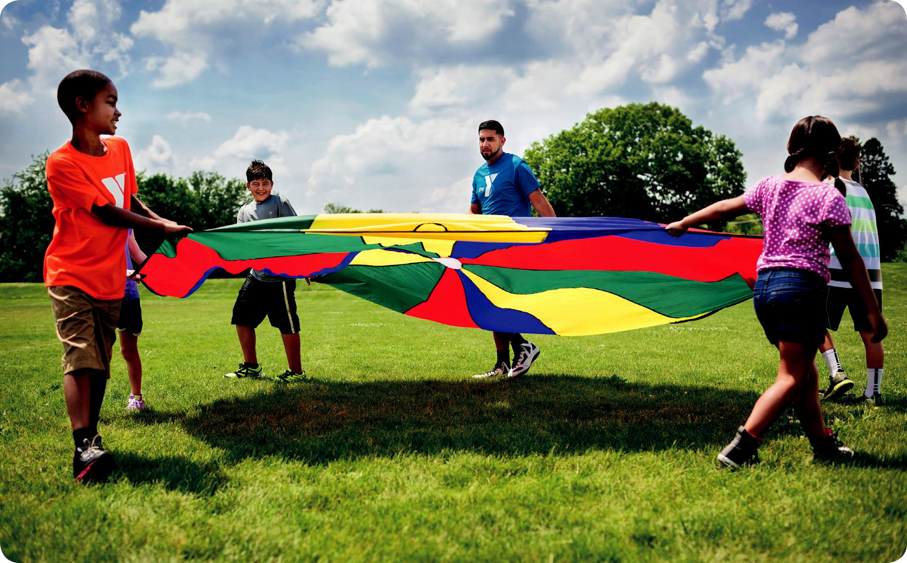

Daily Information
(Please review our parent handbook in regards to issues of illness, medication, incident reports and termination)
Camp hours begin at 7:00 am

Each child must be signed in daily with a YMCA staff member before you leave camp no later than 9 am.
We encourage you to pick your child up after 4 pm so your camper can finish their last camp activity. If you need to pick up your child earlier, please let our day camp sign in staff know, so we can have your child ready.
Camp ends at 5:30 pm
You must sign out your camper daily with a camp staff member before leaving camp. We check to ensure each camper is signed out by an authorized adult. Please make sure your authorized pick-up list is updated to reflect all people that may pick up your child from camp.
Late pick-ups may result in an additional fee.
If your child will be absent from camp that day, please be sure to inform us by calling 561-727-3774

Leadership at YMCA of the Palm Beaches Day Camp
All camp staff members are selected for their excitement to work with children and undergo a training program prior to the beginning of summer camp. Character reference and background checks are conducted for all positions. Our year-round camp staff and coordinators have extensive experience in camp leadership. We put a great deal of effort into finding the finest young people to lead and inspire our campers.

COVID-19 Screening Upon Arrival
To better ensure the safety of our children and families, children and adults with a temperature of 100.4 or above or other signs of illness will not be admitted to the program. We encourage parents to be on alert for signs of illness in their child and keep them home when they are sick.

Health History Form and Liability Waiver
It is very important that you provide us with complete emergency contact information, health history and consent form. A Liability Waiver is also required for each camper.

Daily Packing List

Label everything with your camper’s name:
Lunch/Snacks (Included with Preschool); Swim gear; Towel; Water bottle; Sunscreen (lotions only); Closed-toe shoes - campers are not allowed to wear flip flops or other open-toe sandals except for going to the pool; Backpack to carry belongings

Please do not bring the following to camp:
Phones, Electronics, Knives/Firearms, Weapons, Fireworks, Personal recreation/Sports equipment, Pets, Aerosol sprays, Money, Alcohol/Drugs and Cigarettes.

Insurance/Lost & Found

Parents or guardians are responsible for any medical costs incurred as a result of injury or illness while their child is at camp. Be sure to provide accurate information regarding your health insurance on the Health History Form. YMCA Camp and its staff are not responsible for any lost, stolen, or damaged possessions and we ask that you please label all personal belongings.

PLEASE CIRCLE & INITIAL ABOVE THE SELECTED WEEK(S) YOUR CHILD IS ATTENDING OUR

IGNITE THE EXCITEMENT DAY CAMP

_{Week 1 (Jun 6-10)} _{Week 2 (Jun 13-17)} _{Week 3 (Jun 20-24)} _{Week 4 (Jun 27-Jul 1)}
_{Week 5 (July 4-8)} _{Week 6 (July 11-15)} _{Week 7 (July 18-22)} _{Week 8 (July 25-29)} _{Week 9 (Aug 1-5)}

Payment Authorization
What is the YMCA electronic transfer plan?
The program provides a way to budget your fees on a weekly basis. With your authorization, fees are deducted weekly from an account of your choosing.
What are the benefits of such a program?
Convenience: You save time and mailing costs. With our automatic electronic transfer, there are no checks to write, no stopping at the customer service desk every week.
No additional fees: There are no extra charges for using the
YMCA’s electronic fund transfer payment plan.

Who can participate?
Any adult, 18 years of age and older, who has an account (checking or credit) at a participating financial institution.

How do I sign up?
By completing this authorization card and returning it along with a voided check (if applicable). The check must be preprinted with a customer’s name on it. We will then complete our verification process.

Authorization agreement
I hereby authorize the YMCA to initiate electronic fund entries to my: □ Checking Account □ Credit Card
indicated below, and I authorize the financial institution named below to debit my account.
Financial Institution: _________________________________
City, State: _________________________________________
Routing/Transit Number: ______________________________
Account Number: ____________________________________
Type of Credit Card (circle): Visa Mastercard Amex Discover
Credit Card Number: _________________________________
Expiration: _________________________________________
Name on Card: ______________________________________
This authorization remains in effect until the YMCA has received a five business day written notification from me indicating my desire to discontinue.

Terms and Conditions
1. I understand that this is a continuous plan-based registration and associated fees that will be drafted on the Friday before the following week’s camp.
Parent’s initials: ___________

2. I understand that if I wish to terminate attendance, I must give the YMCA a 5-day written notice and complete a cancellation form. I understand that my account may be drafted during this 5-day period.
Parent’s initials: ___________

3. Two, nonrefundable, fees will be charged up front. A $45 registration fee and a $25 per-week reservation fee must be paid in full in order to reserve my child’s spot. If these fees are not paid, the YMCA cannot guarantee a spot for my child in the Summer Camp.

Parent’s initials: _____________

Child’s Name:
Parent’s Signature:

_____________________________________
_____________________________________

WEEKLY CAMP RATES | Registration Fee | YMCA Family Members | Community Members
Early Registration (Before May 7th) | $45 | $160/week | $180/week
General Registration | $45 | $170/week | $190/week

YMCA CONFIDENTIAL HEALTH HISTORY AND CONSENT FORM

Child’s Name: First: Last: Gender: M F
Address: |  |  |  |  |  |  | Home Phone:
Birthdate: / / | School: |  |  |  |  |  | Grade (in the Fall): |  | Age:
Height: Weight: | Hair Color: |  |  |  | Eye Color: |  | Birthmarks/scars:
- Caucasian | - Native American | - Hispanic |  | - African American |  | - Asian/Pacific Islander |  | - Other
Parent/Guardian 1: Name: |  |  |  |  | Address:
Home Phone: |  |  | Cell Phone: |  |  |  | E-mail:
Employer: |  |  | Birthdate: / / |  |  |  | Work Phone:
Parent/Guardian 2: Name: |  |  |  |  | Address:
Home Phone: |  |  | Cell Phone: |  |  |  | E-mail:
Employer: |  |  | Birthdate: / / |  |  |  | Work Phone:

EMERGENCY CONTACTS WITH PERSONS AUTHORIZED TO PICK UP CHILD
In the case of an emergency, we will always contact the parent/guardian first. In the event a parent/guardian cannot be reached, we will contact other friends/ relatives. No adults other than the parent/guardian or people listed below can pick up your child from our program without a legibly written, dated and signed note from the parent/guardian.
Name: | Cell Phone: | Alternate #: | Relationship:
Name: | Cell Phone: | Alternate #: | Relationship:
Name: | Cell Phone: | Alternate #: | Relationship:

MEDICAL CAREGIVERS
Family Physician: Preferred Hospital:

Doctor’s Phone: Doctor’s Address:

Family Dentist: Dentist’s Phone:

Dentist’s Address:
Medical Insurance Company: | Policy #:
*Immunization History: Tetanus: (MONTH/YEAR) | Tuberculin (TB) Test: (MONTH/YEAR) | MMR: (MONTH/YEAR) | DPT: (MONTH/YEAR)
* PRESCHOOL PARTICIPANTS: A copy of your child’s current immunization record is required.
* YMCA CAMP PARTICIPANTS: A copy of your child’s current immunization record is required.

MEDICAL HISTORY  - ADD/ADHD | - Asthma | - Bed Wetting | - Bleeding/Clotting Disorder | - Celiac Disease
- Chicken Pox | - Currently under Dr. Care | - Diabetes | - Ear Infection | - German Measles
- Head Lice | - Heart Defect/Disease | - Measles | - Migraines | - Psychological Conditions
- Hospitalizations | - Seizures | - Sleepwalking | - Tuberculosis
List Other Medical History Here:

Allergies:  - Pollen | - Penicillin | - Poison Oak | - Bee Stings | - Bee Sting Kit
- Foods | - Hay Fever | - Other Insect Stings | - Other Drugs | - Other Allergies?

List Other Allergies Here:

List Dietary Restrictions Here:

CHILD RESTRICTIONS/PROGRAM ADJUSTMENTS
List any disabilities or restrictions on physical activities:

List any past serious medical treatment such as operations, injuries, diseases, or recurrent illnesses:

Is your child currently involved in therapy/treatment? □ YES □ NO Please explain:

Does your child require special accommodations? □ YES □ NO Please explain:

If your child has special needs, please let us know during enrollment. We want to provide the best environment for everyone and will make reasonable accommodation to fully include every child in activities. Failure to inform the Y at time of enrollment may result in a delayed program start date as we work to provide the appropriate accommodations.

MEDICATION DISBURSEMENT AUTHORIZATION
If your child is currently taking prescription medications, complete this section. For your child’s protection, our staff cannot administer medication without this form. Any medicines that you give us for your child must be in the original container with dosage directions and/or doctor’s instructions clearly labeled. Medication will be administered and documented according to directions on the bottle or by a doctor’s instructions.
Medical Condition: Medication: Amount to be given: When:
Comments or Instructions:
Parent/Guardian Signature: |  | Date:

SWIMMING/SUNSCREEN INFORMATION
Some YMCA programs may include swimming activities with certified lifeguards on duty. For your child’s safety, every child with permission to swim, regardless of swimming ability, will have to take a YMCA swimming test prior to swimming.
My child has permission to participate in YMCA swimming activities. YES NO
The YMCA staff may apply sunscreen to my child’s exposed skin (not covered by clothing/swimsuit), as needed. YES NO

PHOTO/VIDEO RELEASE
I hereby consent to and authorize the use and reproduction of any and all photographs and video which have been taken of my child for the promotional purposes of the YMCA, or anyone authorized by the YMCA. I understand I receive no reimbursement for allowing my child’s photo or video to be taken and the use of the photo or video.

MEDICAL RELEASE
This health history is correct, so far as I know, and the person herein has permission to engage in all prescribed program activities. I assume that the YMCA of the Palm Beaches assumes no financial obligation for such treatment but, in the event that I cannot be reached for an emergency, I hereby give permission to the physician selected by the YMCA to order X-rays, routine tests, and secure proper treatment, hospitalize, and to order injections/and/or anesthesia and/or surgery and emergency treatment for my child as named on this form. All immunizations required for school are up to date.
I agree to and understand the following guidelines: Participants agree to abide by the rules and regulations set by the YMCA for the health, safety, and welfare of all children. Children are not allowed to smoke, chew tobacco, possess any smoking materials, alcohol, illegal drugs, firecrackers or explosives, weapons, use lewd conduct, and inappropriate touching of any kind. Willful destruction of property will be the financial responsibility of the child’s parent. Children may not leave the property or established boundaries without YMCA staff permission.
YMCA of the Palm Beaches reserves the right and will send anyone home (at parents’/guardians’ expense and liability) who violates these rules. It is the responsibility of the parent/guardian to pick up or arrange transportation home for the child. The Child Care Director/Camp Coordinator/Executive Director reserves the right to determine what constitutes a violation of these rules and will enforce them as necessary.
Parent’s/guardian’s signature is required on the Photo Release, Medical Release and agreement to follow YMCA policies and guidelines in order for your child to participate in the YMCA program.

PARENT/GUARDIAN/CUSTODIAL ADULT SIGNATURE: DATE:

Minor Participant Waiver, Release, Indemnification of All Claims & Covenant Not to Sue

NOTICE: THIS IS A LEGALLY BINDING AGREEMENT. Read this document carefully and in entirety. By signing this agreement, you give up your right and the named minor’s right to bring a court action to recover compensation or obtain any other remedy for any personal injury or property damage however caused arising out of the named minor’s participation in the YMCA of the Palm Beaches Programs, now or any time in the future.
Acknowledgment of Risk
I, in my legal capacity as the parent/guardian of the minor named below, do hereby acknowledge and agree that participation in Summer Day Camp activities comes with inherent risks. I have full knowledge and understanding of the inherent risks associated with Summer Day Camp participation, including but in no way limited to: (1) slips, trips, and falls, (2) aquatic injuries, (3) athletic injuries, and (4) illness, including exposure to and infection with viruses or bacteria. I further acknowledge that the preceding list is not inclusive of all possible risks associated with Summer Day Camp participation and that said list in no way limits the operation of this Agreement.
Coronavirus / COVID-19 Warning & Disclaimer
Coronavirus, COVID-19 is an extremely contagious virus that spreads easily through person-to-person contact. Federal and state authorities recommend social distancing as a mean to prevent the spread of the virus. COVID-19 can lead to severe illness, personal injury, permanent disability, and death. Participating in the YMCA of the Palm Beaches’ programs or accessing the YMCA of the Palm Beaches’ facilities could increase the risk of contracting COVID-19. The YMCA of the Palm Beaches in no way warrants that COVID-19 infection will not occur through participation in YMCA of the Palm Beaches’ programs of accessing YMCA of the Palm Beaches’ facilities.

Initial

Waiver, Release, Indemnification & Covenant Not to Sue
In consideration of ____________________’s participation in the YMCA of the Palm Beaches’ Summer Day Camp Program, I, ____________________, the parent/guardian of the minor named above, agree to release and on behalf of myself and the minor named above, my heirs, representatives, executors, administrators, and assigns, HEREBY DO RELEASE the YMCA of the Palm Beaches, its officers, directors, employees, volunteers, agents, representatives and insurers (“Releasees”) from any causes of action, claims, or demands of any nature whatsoever including, but in no way limited to, claims of negligence, which I, the named minor, my heirs, representatives, executors, administrators and assigns may have, now or in the future, against The YMCA of the Palm Beaches on account of personal injury, property damage, death or accident of any kind, arising out of or in any way related to the use of YMCA of the Palm Beaches’ facilities/equipment or participation in the YMCA of the Palm Beaches’ programs whether that participation is supervised or unsupervised, however the injury or damage occurs, including, but not limited to the negligence of Releasees.

Initial

In consideration of the named minor’s participation in Summer Day Camp, I, the undersigned parent/guardian of the named minor, agree to INDEMNIFY AND HOLD HARMLESS Releasees from any and all causes of action, claims, demands, losses, or costs of any nature whatsoever arising out of or in any way related to the named minor’s Summer Day Camp participation.
I hereby certify on behalf of myself and the named minor that I have full knowledge of the nature and extent of the risks inherent in Summer Day Camp participation and that I, on behalf of myself and the named minor, am voluntarily assuming said risks. I understand that I and the named minor will be solely responsible for any loss or damage, including personal injury, property damage, or death, the named minor sustains while participating in Summer Day Camp and that by signing this agreement I, on behalf of myself and the named minor, HEREBY RELEASE Releasees of all liability for such loss, damage, or death. I further certify that the named minor is in good health and has no conditions or impairments which would preclude his/her safe participation in Summer Day Camp.
I further certify that my date of birth is _____________ (MM/DD/YYYY), that my present age is ______, that I am therefore of lawful age (18 years or older) and otherwise legally competent to sign this agreement, and that I have legal capacity to act as the parent/guardian of the named minor. I further understand that the terms of this agreement are legally binding and certify that I am signing this agreement, after having carefully read it, of my own free will.

___________________________________ _____________________________________
Participant Name (Print Clearly) Date
___________________________________ _____________________________________
Parent/Guardian Signature Parent/Guardian Name (Print Clearly)

ALL ABOUT ME!
Camper’s Name: Last
A LETTER TO MY YMCA CAMP Counselor

Dear Camp Counselor,

My name is (first and last) . I like to be called: and at camp I will be years old. In the fall I am entering grade at School. I live with: . The language I speak at home is ,
at school I speak .
My comfort level with English is (circle): (I do not speak any English) 1 2 3 4 5 (I am a native speaker)
When I am not in school, I like to:

. My favorite things are: (food, books, movies, colors, other)
. I am excited about camp this summer because:
First
. I prefer ___ hanging out with friends __spending time on my own.
I cannot wait to do this at camp:

. I am a little nervous about:
. I would like a counselor who is:
.
Session

.

Parents,
Camper's Name: Last ______________________________________________________________ First ________________________________________________ Session _______________________

Your help completing this form will help your camper have the best possible experience.

How does your child interact with other children? (Check all that apply)

_ Shy | __ Friendly | __ Aggressive | __Outgoing | __Follower
__Leader | __Quiet | __Silly | __Indifferent
How does your child interact with adults? (Check all that apply)

__Shy | __Friendly | __Aggressive | __Outgoing | __Follower
__Leader | __Quiet | __Silly | __Indifferent
Has your child expressed any concerns about the upcoming camp experience?

Are there concerns about your child’s camp experience?

What is your child’s current school status? Is behavior an issue?

Has anything occurred in your camper’s/family’s life in the past year that may be a concern or that may affect behavior at camp?

Brief summary of your child that might help us better understand him/her:

Is there anything you would like us to know? Are there any activities you do not want your child to participate in?

PERMISSIONS
I hereby give the YMCA permission to take my child on supervised walking excursions: _____Yes _____No
I hereby give the YMCA permission to take my child out for structured games/activities: _____Yes _____No
I hereby give the YMCA permission to take my child on a walking field trip to the pool: _____Yes _____No
I hereby give the YMCA permission to take my child swimming: _____Yes _____No

Signature Parent/Guardian Date

YMCA OF THE PALM BEACHES
Camper Code of Conduct

It is the goal of YMCA of the Palm Beaches Camp to provide a healthy, safe, and secure environment for all day camp participants. The YMCA teaches the core values of Respect, Responsibility, Honesty and Caring. Children attending the
program are expected to follow the behavior guidelines and appropriately interact in a group setting.

PROGRAM BEHAVIOR GUIDELINES
- People are RESPONSIBLE for their actions.
- RESPECT each other and the environment.
- HONESTY will be the basis for all relationships and interactions.
- We will CARE for ourselves and those around us.

WHEN A CHILD DOES NOT FOLLOW THE BEHAVIOR GUIDELINES, THE FOLLOWING STEPS WILL BE TAKEN
- Staff will redirect the child to more appropriate behavior.
- The child will be reminded of the behavior guidelines and rules, and a discussion will take place.
- The parent will be notified of the problem.
- The staff will document the situation. This written documentation will include what the behavior is, what provoked the problem, and corrective action taken.
- A phone call with the parent and staff will occur to determine the appropriate action.
- A progress check or follow up will occur.
- If the problem persists, a second phone call will occur with the parent, child, staff and Camp Coordinator/Child Care Director. Camp Coordinator/Child Care Director will have all documentation and notes for review. Continued participation may require counseling and a behavior contract.
- If a child’s behavior at any time threatens the immediate safety of self, other children or staff, the parent will be notified and expected to pick up the child immediately.
- If a problem persists and/or a child continues to disrupt the program, the YMCA reserves the right to dismiss a child from the program.
- Removal from the program will be considered in situations involving violent acts or after all alternatives have been attempted to resolve the problem.

IMMEDIATE REMOVAL FROM PROGRAM
- Endangering the health and safety of the children and/or staff.
- Threats made to children and/or staff regarding firearms, knives, firecrackers or explosives.
- Theft or damage to YMCA or personal property.
- Leaving the program without permission.
- Continuous disruption of the program.
- Refusal to follow program behavior guidelines.
- Use of profanity, vulgarity, and/or obscenity.
- Lewd behavior.

IMMEDIATE EXPULSION
- Possession of and/or use of tobacco, knives, alcohol, illegal drugs, firecrackers, firearms or explosives.
- Inappropriate interaction by parents or family towards other parents, participants or staff. (Example: fights, hostile, etc.)

PARENT/GUARDIAN SIGNATURE REQUIRED
I have reviewed the Behavior Management Procedures with my child. I understand and agree to all of the terms presented in this document.

Parent/Guardian Signature Date

Child Signature Date

